CSA6303 - THREAT INTELLIGENCE AND NETWORK SECUR
Assessment Tool 1: CONCEPT MAPPING
Faculty : Dr.V.Parthipan SLOT A
Topics: Network Security Fundamentals | Security Goals (CIA Triad) | Types of Network Threats
|Introduction to Threat Intelligence Types of Threat Intelligence (Strategic, Tactical, perational) — Threat Intelligence Lifecycle — Applications in IT Industry
CO1: Interpret security principles, network threats, and the role of threat intelligence in cybersecurity.
Total: 50
Student Name :P.Venkta Pranava Sesha Sai Register number: 192311128
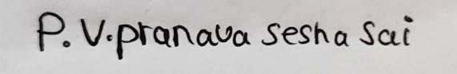
Code of Conduct:
I P. Venkata Pranava Sesha Sai(192311128) (Name / Reg No) certify that this submission is my original work and that I have adhered to the guidelines specified for this assessment. I understand that any violation of academic integrity rules will result in disciplinary action.
Signature of the student
5.Construct a concept map explaining the concept of Threat Intelligence and its role in modern network security. Relate threat actors, indicators, vulnerabilities, attack patterns, threat information, analysis, and actionable intelligence to demonstrate how Threat Intelligence helps organizations anticipate and respond to network threats.

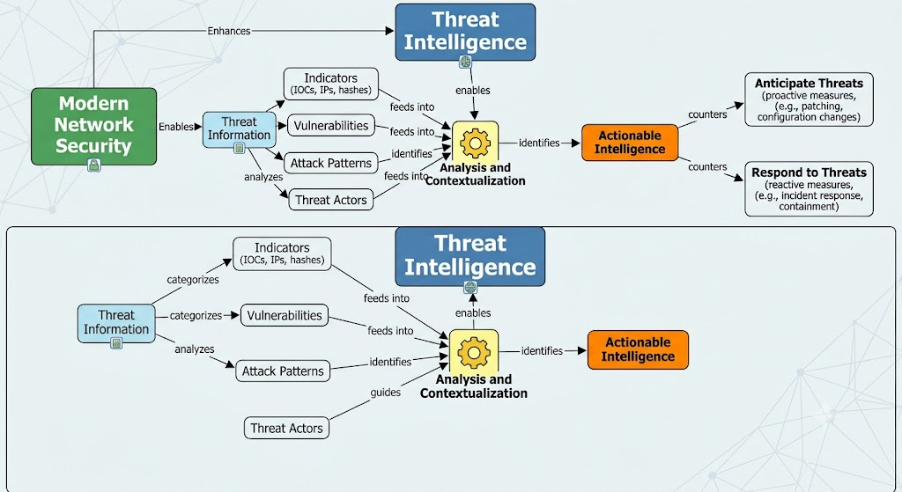

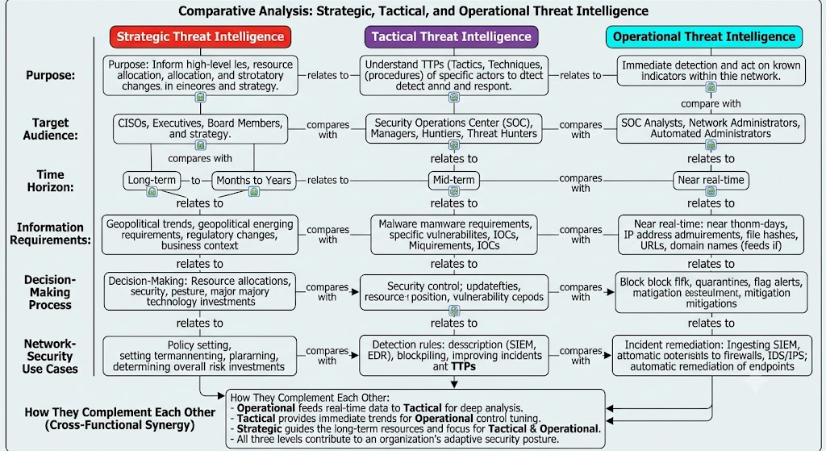
6.Develop a comparative concept map of Strategic, Tactical, and Operational Threat Intelligence. Connect each type with its purpose, target audience, time horizon, information requirements, decision-making process, and appropriate network-security use cases, and analyze how the three intelligence types complement one another.

